ls:



cd :



Mkdir:



Cp:

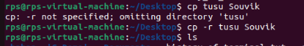

Mv :

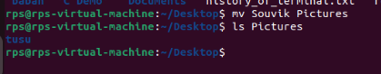

Pwd:



Less:

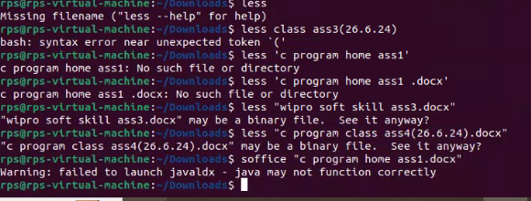

Rm:

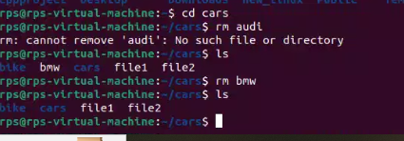

More & Cat :

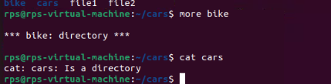

Commands:

ls

ls –a

ls –la

ls –Fa

Output:

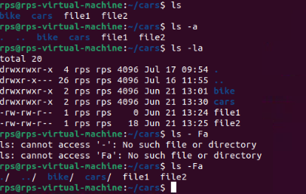

Commands:

mkdir linux

pwd

cd linux

pwd

cd

pwd

rmdir linux

Output:

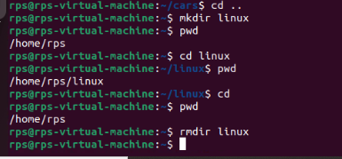

•Relative Path

  pwd

  cd .

  pwd

  cd ..

  pwd

  cd ..

  pwd

  cd

Output:

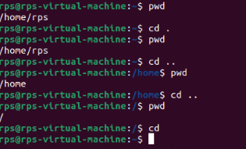

Ablsoute Path

  cd

  mkdir mydir

  pwd

  cd /Users/invite

  pwd

  cd /Users

  pwd

  cd /

  pwd

  cd /Users/invite

  cd ~/mydir

Output:

